New Member

About Copyworld
Copyworld started as a small copy shop 31 years ago with one black and white and one colour photo copier and a fax machine. Today, it is one of the largest digital print shop in the Eastern Cape with a staff compliment of 58 staff members and based in the centre of a business hub in East London. Our exceptional quality products range from business cards to high volumes of colour and black and white prints hot off our latest Irredesse Production Presses with our wide format department boasting a variety of vinyl and hexflex products in large scale. We pride ourselves with continuing to stay up to date with the latest technology on the market which assists in producing products of a high quality. We strive to deliver within quick turnaround times with a focus on quality and service.
We are however, more than just a print shop and offer a number of services making it a one stop shop. We also provide corporate clothing, promotional gifts and branding.

Message from the Director
Steve Beaumont
In an industry continuously evolving at a rapid pace with exciting new products and technology, we as a company can only positively benefit from a platform such a Printing SA.
We pride ourselves with delivering a high-quality product and service and continue to strive to be a deserving competitor in this market. Therefore, being a member of Printing SA can assist us by means of training, events, marketing and up to date information about the printing industry.
We look forward to this partnership as a valuable contribution in achieving our goals and making our mark in this very competitive industry
Website - www.hitechgraphics.co.za
Logo
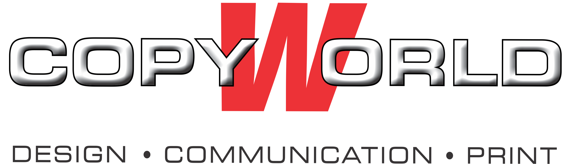

Cover Picture
