The African Continental Free Trade Area (AfCFTA) To Boost Creative Industry
Very Important: Please complete a quick 3 minute survey at the end of the article
The African Continental Free Trade Area (AfCFTA) kicked off on 1 January 2021. The trade pact seeks to create a single market for goods and services and promote cross-border movement of capital and people. Currently the intra-African trade is at 18% of regional integration. The AfCFTA is expected to lift around 68 million people out of poverty and make African countries more competitive.
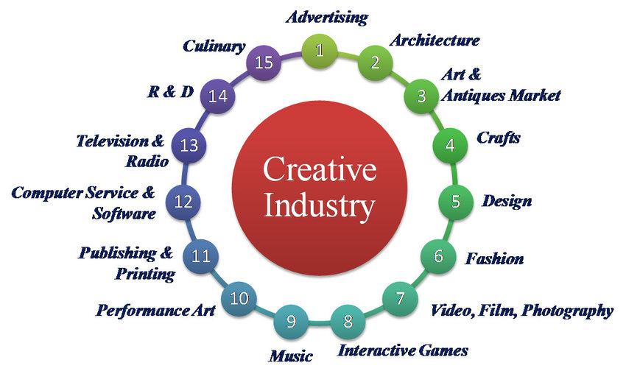
Orange economy
The trade pact facilitates job creation and greater competitiveness of African micro, small and medium-sized enterprises (MSMEs) and expected to generate jobs for young people and boost the creative and cultural industries which also called the 'orange economy'. These include visual and performing arts, crafts, publishing and printing, cultural festivals, photography, music, dance, film, fashion, video games, digital animation, architecture, and more.
Digital Economy
A report by the International Trade Centre states that the AfCFTA agreement can create more jobs and entrepreneurship opportunities for young Africans, youth can also take advantage of an AfCFTA protocol on e-commerce, which underscores the importance of the digital economy.
Printing SA regularly monitors the AfCFTA progress and liaises with the Department of Trade, Industry and Competition. Under the trade in goods, it is anticipated that by February 2022, the AfCFTA tariff book will be published to include the customs procedures that apply to products and rules of origin. Traders will be able to identify in that tariff book their specific products, know what rules of origin apply to each product and associated tariffs.
Trade in Services, and expand beyond SA
The preliminary process on trade in services is ongoing to eliminate the non-tariff barriers to trade which will add value significantly to the creative sector. Companies are advised to exploit digital opportunities and expand beyond South African borders without incurring operational cost.
Printing SA has developed a survey to gather information to assist AfCFTA negotiators to focus on specific countries in our sector and with whom member companies would like to trade with. If our sector is excluded, it will not create positive conditions for investments or commercial contracts to provide such services in other markets. For example, if a South African investor has challenges in the specific country it would be very difficult to address issues under trade law provisions or dispute mechanisms. To avoid this there should be commitments to clarify best treatment conditions for investors and service suppliers so they can trade and invest, limiting risk from arbitrary government or regulatory decisions.
Click to complete the survey in 3 minutes and return on or before 2 February 2022.
Click here to read AfCFTA explained
For any comments/ questions write an email to kntanzi@printingsa.org

