-

Step by step guide to complete TERS application online

Printing SA

5TH May 2020

Table of Contents

1. Preamble 3

2. Amended Covid-19 TERS (C19 TERS) 3

3. Amendment to (C19 TERS) directive of 16 April 2020 5

4. TERS correction notice 5

5. Online TERS submission 7

6. Required documents 9

7. Completion of national disaster payment template (Annexure B) 9

7.1 Column A (UIF reference number) 10

7.2 Column B (Shutdown from DD-MMM-YYYY) 10

7.3 Column C (Shutdown to DD-MMM-YYYY) 10

7.4 Column D (Tradename) 10

7.5 Column E (PAYE number) 10

7.6 Column F (Contact number) 10

7.7 Column G (email address) 10

7.8 Column H (ID number) 10

7.9 Column I (First name) 10

7.10 Column J (Surname) 10

7.11 Column K (Remuneration monthly) 10

7.12 Column L (Employment start date DD-MMM-YYYY) 11

7.13 Column M (Employment end date DD-MMM-YYYY) 11

7.14 Column N (Sector minimum wage) 11

7.15 Column O (Remuneration received during shutdown period) 11

7.16 Column P (Bank name) 11

7.17 Column Q (Branch code) 11

7.18 Column R (Type account) 12

7.19 Column S (Account number) 12

7.20 Column T (Preferred payment medium) 12

8. Employee applications for TERS 12

9. FAQ COVID-19 TERS 13

10. Enquiries regarding submitted claims 13

11. Further Assistance 13

# 1. Preamble

On 26 March 2020, the Department of Labour issued a notice releasing the COVID-19 Temporary Employer Relief Scheme (TERS) in response to the National Lockdown. This notice is very specific in dealing with the payment of salaries and wages during the lockdown period. It expressly states that in the event where an employer is able to pay employees, they are encouraged to do so, however where the same is not economically possible, government has created a special benefit under the UIF called TERS for which employers can apply.

# 2. Amended Covid-19 TERS (C19 TERS)

2.1 On 8 April 2020 the Department of Labour issued an amended Covid-19 TERS (C19 TERS) directive.

<https://www.gov.za/sites/default/files/gcis_document/202004/43216gen240.pdf>

2.2 The amended directive as follows:

Clause 1.1.7 “**Temporary lay-off”** means a reduction in work following a temporary closure of the business operations, whether **total or partial**, due to the Covid-19 pandemic for the period of the National Disaster.

Clause 3.1 refers to should an employer as a result of the Covid-19 pandemic close its operations, **or part of its operations**, for **a 3 (three) month period or lesser** period affected employees shall qualify for a Covid-19 benefit.

Clause 3.4, 3.5 & 3.6 gives more clarity on how the benefit will be calculated on the sliding scale (38%-60%) as provided in the UI Act. (maximum of R17712 per month). Where the % on the sliding scale is below R3500, the employee will receive R3500.

For example:

On a salary of R40 000 per month calculated on the maximum amount of R17 712 per month will be used. 38% of R17 712 = R6730 benefit.

On a salary of R5 000 per month.

60% of R5000 = R3000 benefit – **employee to be paid R3500**

Clause 5.3 indicates that subject to the amount of the benefit contemplated in clause 3.6 an employee **may only receive Covid-19 benefits** in terms of the directive if the total of the benefit together with additional payment by the employer in the period **is not more than the remuneration** that the employee would ordinarily receive for working during the period.

The clause may lead to confusion and can be interpreted in 2 ways:

1. If the employer payment (even partially) together with TERS exceed the normal remuneration no benefit is due through TERS.
2. TERS will only pay the benefit equal to the difference between the remuneration paid and outstanding balance, if its not more than the employees’ normal remuneration.

Clause 3.8 refers to employers whose employees are entitled to receive covid-19 benefits provided by the Fund during the period of lockdown from a bargaining council may not make an application in terms of the scheme and the employees of that employer may not receive any payment in terms of the scheme than through the bargaining council.

This can only take place where the following is in place:

1. A collective agreement between the parties and the bargaining council that has been extended.
2. by the Minister of Employment and Labour in terms of section 32 of the Labour Relations Act, 1995 (Act No. 66 of 1995); and
3. Provides for the disbursement of funds received from the Unemployment Insurance Fund to provide covid-19 benefits to employees bound by the collective agreement during the period of lock-down; and
4. The bargaining council has concluded a memorandum of agreement with the Unemployment Insurance Fund for the council to disburse covid-19 benefits on behalf of the Fund.

Clause 5.4. refers to no payment from the Unemployment Insurance Fund to the Bargaining council or employer will fall under general assets and cannot be withheld by any bank irrespective of any overdraft or other contractual obligations.

# 3. Amendment to (C19 TERS) directive of 16 April 2020

The Department of Employment and Labour has issued an amended government notice in terms of the TERS funding scheme. The regulations are not a massive departure from the previous regulations but have clarified the following issues:

1. The TERS benefit is available for employees who had to take annual leave during the lock down.
2. Employers must file the application on behalf of its employees.
3. **Employers who required employees to take annual leave during this period may set-off any funding received from the TERS scheme against the amount paid to an employee in terms of annual leave, provided that the employee is credited with the proportionate annual leave days;**
4. Employers, under the scope of a Bargaining Council which has entered into an agreement with the UIF, do not need to apply through the Council if they have already applied to the UIF directly prior to the agreement being concluded; and
5. Employers are encouraged to advance payments to employees and recover such amounts from the TERS.

Click the link here to view the government notice <https://mcusercontent.com/7af202f977bc5dbad675398d7/files/9720cfdb-1fc1-4807-a9cb-ae368bcfdffe/Labour_Directive_of_16_April_2020.pdf>

# 4. TERS correction notice

In an effort to clear benefits pay out to employees regarding the Covid-19 TERS, the Minister of Employment and Labour signed a correction notice on 20 April 2020. See link below

<http://www.labour.gov.za/DocumentCenter/Regulations%20and%20Notices/Notices/Unemployment%20Insurance%20Fund/Amendment%20and%20Correction%20of%20Directives%20by%20the%20Minister%20of%20Employment%20and%20Labour.pdf>

1. Clause 2.1.1 (a) is corrected by the deletion of the reference to section 22(10) and replaced by section 20(10) which refers to Annual leave in the Basic conditions of employment Act (BCEA).

Annual leave must be taken –

(a) in accordance with an agreement between the employer and the employee; or

(b) if there is no agreement in terms of paragraph (a), at a time determined by the employer

Accordance with this section.

1. Clause 3.6 is corrected by the deletion of section ‘12’

Qualifying employees will receive benefits calculated in terms of section13 (1) and (2) of the UI Act, provided that an employee shall receive a benefit of no less than R3 500. See below the link to the UI Act.

<https://www.gov.za/sites/default/files/gcis_document/201409/a63-010.pdf>

**UI Act of 2002**

13. Calculation of benefits

13(1) Subject to subsection (2), for the purposes of calculating the benefits payable to a contributor, the daily rate of remuneration of a contributor, subject to the prescribed maximum, must be determined-

(a) if paid monthly, by multiplying the monthly remuneration by 12 and dividing it by 365;

(b) if paid weekly, by multiplying the weekly remuneration by 52 and dividing it by 365.

(2) If the contributor’s remuneration fluctuates significantly from period to period, the calculation must be based on the average remuneration of that contributor over the previous six months.

1. Clause 3.8.2 (ii) is corrected by the deletion of ‘and’ after the semi-colon and replaced by and/or

Provides for the disbursement of funds received from the Unemployment Insurance Fund to provide covid 19 benefits to employees bound by collective agreement during the period of lock-down and or the bargaining council has concluded a memorandum of agreement with the Fund of the council to distribute Covid-19 benefits on behalf of the Fund to -

(This refers to Bargaining council and collective agreements)

1. Clause 5.4 is corrected by the deletion of the reference to ‘section 22(10)(b)’ and replaced by ‘section 20(10)(b)’.

An employer who has required an employee to take annual leave during the lockdown period in terms of section 20(10)(b) of the Basic Conditions of Employment Act. 1997 (Act 75 of 1997), may set of any amount received from the UIF in respect of that employees COVD 19 benefit against the amount paid to the employee in respect of annual leave provided that the employee is credited with the proportionate entitlement to paid annual leave in the future.

# 5. Online TERS submission

5.1 UIF have developed an online portal to lodge claims under the COVID19 Temporary Relief Scheme.

5.2 Type URL [**https://uifecc.labour.gov.za/covid19/**](https://uifecc.labour.gov.za/covid19/) and use the Easy Aid and online guide document attached to assist yourself through the process **(Annexure A).**

5.3 The online system only permits you to proceed to the next step if the previous steps were completed correctly.

5.4 Do 1 online submission for your business including both wage and salary employees.

5.5 If you are not sure what your **UIF Reference Number with Department of Labour** is, you can get it by clicking on get your UIF reference number and then typing in your PAYE Number (from SARS) and

click on "Get UIF Reference". See screenshot below:

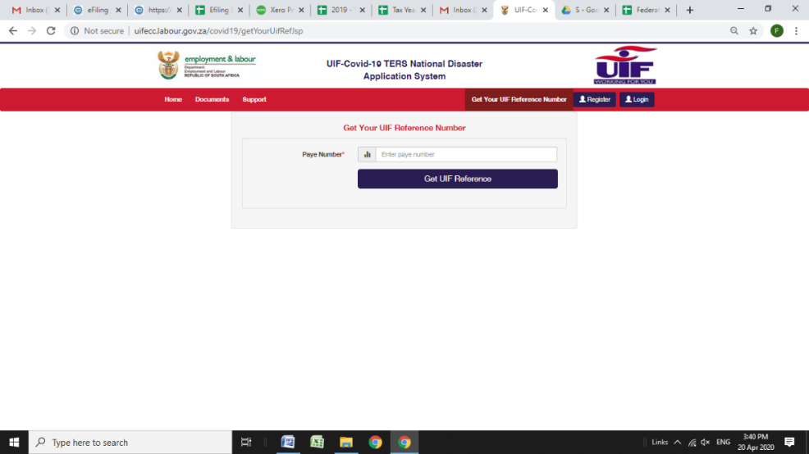

5.6 Under Covid-19 TERS registration, select employer/company. Complete requested information and

and create your password.

5.7 After this has been done you can login the online system.

Username – UIF reference number

Password – Newly created password

5.8 Under UIF Covid-19 TERS entity details screen the following information would be requested this is the business information.

1. UIF reference number
2. Tradename (Insert the name under which your business is registered under with UIF)
3. PAYE number
4. Contact number
5. Lockdown dates (Select the date range applicable to your business)
6. Payment medium

* Select payment to **employer** for 10+ employees

**\*Optional** - Select payment to **employee** for less than 10 employees

1. Address
2. Bank name, branch code, account number & account type (This must correlate with the proof of bank account details that will be uploaded and attached to the application. **Employers are not required to open a separate bank account for TERS payments**)

5.9 The employer can then read through the MOA and accept the terms of the MOA by clicking on the accept button.

5.10 The employer can then read through the letter of undertaking and can accept the undertaking by clicking the accept button.

5.11 Confirmation of banking details to be uploaded. The bank letter confirming banking details must be in PDF format.

5.12 There after the employer can select to upload the csv file, click **yes or no** and capture employee details online.

**Yes** - upload the csv file

**No** - Capture employee details online

5.13 If the employer choose to upload the National disaster payment template excel **(Annexure B)** to be converted to csv file format use the guideline document to convert the excel file into a CSV file **(Annexure C)** for upload onto the online platform. Refer to **paragraph 7** for completion of the national payment details excel file.

5.14 Once the TERS application has been successfully completed online the following message will reflect:

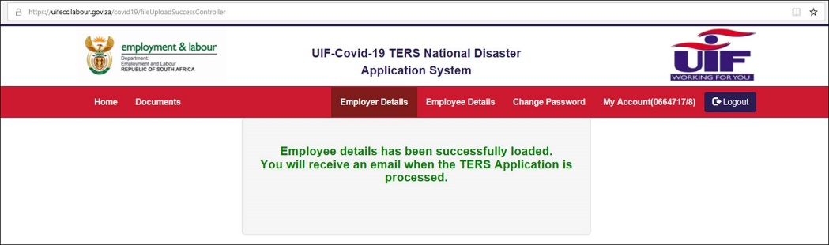

# 6. Required documents

6.1 Confirmation of bank account details must be in PDF format for upload.

6.2 The National disaster payment template to be uploaded in CSV format **is only required if the employer selected to do a CSV file upload**.

# 7. Completion of national disaster payment template (Annexure B)

## 7.1 Column A (UIF reference number)

Insert the UIF reference number that your business is registered with UIF.

## 7.2 Column B (Shutdown from DD-MMM-YYYY)

This is the last date remuneration was received in full by the employee for the shutdown.

For example, 27-Mar-2020 or 01-April-2020

## 7.3 Column C (Shutdown to DD-MMM-YYYY)

Insert the end date of the lock down period being applied for example 30-APR-2020

## 7.4 Column D (Tradename)

Insert the name under which your business is registered with UIF.

## 7.5 Column E (PAYE number)

Insert the business PAYE number.

## 7.6 Column F (Contact number)

Insert the business contact number for example 0116374869 (do not include any spaces),

## 7.7 Column G (email address)

Insert the business e-mail address

## 7.8 Column H (ID number)

Insert the employees ID number – 8301050112089 (do not include any spaces)

For foreign nationals employed include their passport number the difficulties on the system with this has been rectified. For those who have already applied and had payment for foreign nationals declined and/or did not receive payment can send an email to: [covid19compliance@labour.gov.za](mailto:covid19compliance@labour.gov.za) together with passport/permit numbers of those specific employees and proof of payment in order to be assisted with these. For new applications they may proceed as normal.

## 7.9 Column I (First name)

Insert the employees first name for example, Samantha

## 7.10 Column J (Surname)

Insert the employees surname name for example, Knox

## 7.11 Column K (Remuneration monthly)

Insert the employee’s monthly basic salary (no overtime and allowances must be included)

* **Example: 26000.90 – Correct way to input information**
* **Example: R26,000.92 – Incorrect way to input information**

If you have weekly paid wage employees use the below to calculation to convert to a monthly amount.

1. Take the weekly basic salary (no allowances or overtime to be included) and multiply with 4.33 to get the monthly remuneration.

For example, R5000 x 4,33 = R21650.00

This amount must reflect to your February payroll amount.

## 7.12 Column L (Employment start date DD-MMM-YYYY)

Insert the date the employee started employment at the business. Example, 17-JUN-2001

## 7.13 Column M (Employment end date DD-MMM-YYYY)

This is the last date remuneration was received in full by the employee for the shutdown.

For example, 27-MAR-2020 or 01-APR-2020.The UIF TERS online application site currently display the below message.

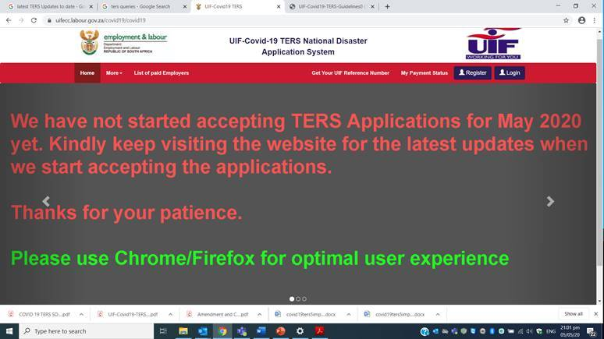

## 7.14 Column N (Sector minimum wage)

The minimum wage that will be used to determine minimum payment to employees is R3500 pm.

## 7.15 Column O (Remuneration received during shutdown period)

Basic salary paid during lockdown/shutdown period if applicable.  This could be 0 earned.

No leave paid to employees should be included in this column.

## 7.16 Column P (Bank name)

Insert the bank name, for example FNB, Capitec, Nedbank etc.

Employees Bank Account details is a mandatory requirement to be completed in column P – S.

## 7.17 Column Q (Branch code)

Insert the employees bank branch code number

## 7.18 Column R (Type account)

Under Account Type value should reflect as below. Please use the **Account Type ID** instead of Account Type description when completing.

|  |  |
| --- | --- |
| **ACCOUNT TYPE ID** | ACCOUNT TYPE |
| **1** | Current Account |
| **2** | Savings Account |
| **3** | Transmission Account |

Only put 1,2 or 3 in column R.

## 7.19 Column S (Account number)

Insert the employee bank account number.

## 7.20 Column T (Preferred payment medium)

Under preferred payment medium can be indicated as follows:

|  |  |
| --- | --- |
| **Payment medium number** | **Payment medium** |
| **2** | Payment to employer |
| **3** | Payment to bargaining council |

It is preferable to choose **2** in column T.

# 8. Employee applications for TERS

The Minister of Employment and Labour has announced measures that the Department will put in place to contain the spread of the Corona Virus (Covid-19) and its impact on UIF contributors. In line with the above regulation, the Minister has announced measures that the Department will put in place under the current special circumstance relating to the Corona virus (COVID-19) and its impact on UIF contributors.

The Unemployment Insurance Fund will assist affected workers through existing benefits including Illness, Reduced Work Time, Unemployment and Temporary employer/ Employee Relief Scheme (TERS) benefits. The Unemployment Insurance Commissioner, after consultation with Unemployment Insurance Fund Executive, has also developed a COVID-19 Temporary Employer/ Employee Relief Scheme (COVID19TERS) to contribute to the containment of the Corona Virus and its impact.

The following is a quick user guide on how to navigate through U-filing to access the COVID-19 TERS Employee Benefit which assists Employees to claim UIF relief**. Employee applications are applicable for the smaller employers who employ less than 10 staff.** Below the link for the user guide.

<https://www.ufiling.co.za/docs/COVID19%20TERS%20EMPLOYEE%20FINAL%20USER%20GUIDE.pdf>

# 9. FAQ COVID-19 TERS

Kindly see below Frequently asked questions released by the Department of Labour regarding Covid-19/ TERS.

<http://www.labour.gov.za/DocumentCenter/Publications/Unemployment%20Insurance%20Fund/COVID%2019%20FAQ...pdf>

# 10. Enquiries regarding submitted claims

Employers who have applied online but who have received no confirmation as to whether the claim has been approved or rejected, should log into the system and use the **"Payment Breakdown Report"** to determine if the claim has been processed, approved or declined, and if declined, for what reason. This **“Payment Breakdown Report”** serves as the payment schedule;

Should you require any further information or have any queries related to your claims lodged, kindly contact the **Department of Labour** on **012 337 1997** or **0800 030 007**

# 11. Further Assistance

***Contact your regional chamber:***

**Cape Chamber** - Susan Petersen [Spetersen@pifsa.org](mailto:Spetersen@pifsa.org)

- Danielle Arendorf [DArendorf@printingsa.org](mailto:DArendorf@printingsa.org)

**Central Chamber** - Elri van Zyl [Evanzyl@printingsa.org](mailto:Evanzyl@printingsa.org)

- Simone Nayager [Snayager@printingsa.org](mailto:Snayager@printingsa.org)

**KZN Chamber** - Jermaine Naicker [jnaicker@printingsa.org](mailto:jnaicker@printingsa.org)

- Terisha Veeran [Tveeran@printingsa.org](mailto:Tveeran@printingsa.org)

**Northern Chamber** - Lana Human [lhuman@printingsa.org](mailto:lhuman@printingsa.org)

*All information supplied is correct as per legislation as on 04 May 2020.* *Although Printing SA endeavours to supply correct and updated information relating to the Covid-19 prescribed government updates and the Department of Labour it does not guarantee the correct interpretation thereof, nor do we accept any liability for any information or statements supplied by external sources herein. The labour laws in South Africa change continuously as well as TERS application procedures and employers should stay up to date with new developments. We accept no responsibility or liability whatsoever for any adverse consequences that may arise, including but not limited to, financial loss, acceptance of claims, delays in pay outs, compensation orders, fines in this regard.*